

**PROJECT**

**DESIGN AND ARCHITECTURAL SCHOOL NETWORK SYSTEMS**

Created by :

* Hatami Alfarizi
* Nurul Amala Azza
* Tevin Dean Ramadhan

Faculty : Indah Ayu Yuliani ST, MM

Semester : 1

Quarter : 1

Class : 1SC1

Continuing Education Center for Computing and Information Technology Faculty of Engineering, University of Indonesia

2017

**Preface**

Thanks to God for give us his blessing to complete the project entitled “Design And Architectural School Network”. The writer also expressing the sincere gratitude for Ms. Indah Ayu Yuliani and other faculty members in order to finish the project. Thanks to the other colleague for supportive critics, insight and helpful corrections for this instance.

This project workpaper contains Theorical Definitions, Architecturals, Topology and Wire/Wireless scheme, Device, Software, Security, and Cost of Network. The works of this project could be useful in future definitions and concept of understanding.

Depok, September 2017

Author

Table of Contents

CHAPTER I: INTRODUCTION 7

1.1 Background 7

1.2 Writing Objective 7

1.3 Problem Domain 8

1.4 Writing Methodology 8

1.5 Writing Framework 8

CHAPTER II: BASIC THEORY 10

2.1 Hardware Definition 10

2.2 Software Definition 16

2.3 Introduction to Network 19

2.4 Network Architecture 21

2.6 Identifying Computer on a Network 25

2.7 Network Media 28

2.8 Network Devices 31

2.9 Network Operating System 35

CHAPTER III : PROBLEM ANALYSIS 37

3.1 Analysis 37

3.2 Network Design 38

3.3 Networking Architecture 39

3.4 Hardware and Software 40

3.5 IP Address 43

3.6 Network Media 45

3.7 Network Operating System 46

3.8 Network System Map 46

3.9 Budgeting 47

**Table of Figures**

Figure 2.1 Keyboard (REF : PCMag.com) 11

Figure 2.2 Visual Display Unit (REF : computerhope.com) 13

Figure 2.3 The main components of computer (REF : ComputerHope.com) 14

Figure 2.4 The example of LAN, MAN, WAN (REF : TutorialKomputerdanJaringan.com) 20

Figure 2.5 Client Server Design (REF : Wikipedia) 21

Figure 2.6 Peer to Peer Design (REF : Wikipedia) 22

Figure 2.7 Geometric layout of workstations of Network Topology (REF : Wikipedia) 24

Figure 2.8 MAC Address (REF : cdn.instructables.com) 27

Figure 2.9 Coaxial Cable (REF : images-na.ssl-images-amazon.com) 29

Figure 2.10 Twisted pair (REF : qph.ec.quoracdn.net) 30

Figure 2.11 Network Interfaces (REF : Wikipedia) 32

Figure 2.12 Switch (REF : Newegg.com) 33

Figure 2.13 Router (REF : Wikipedia) 34

Figure 2.14 Firewalls Example (REF : Comodo) 35

Figure 3.15 The Architectural of rooms (REF : Cisco) 38

Figure 3.16 Network System Map of LAB 1 (REF : Analysis by Group) 46

Figure 3.17 Network System Map of LAB 2 (REF : Analysis by Group) 47

Figure 3.18 Network System Map of Administrator Room (REF : Analysis by Group) 47

**Table of Tables**

Table 2.1 Application Software (REF : Wikipedia) 19

Table 2.2 Classes of IP Address (REF : ComputerHope.com) 27

Table 3.3 The Hardware of School Network (REF : Analysis by group) 41

Table 3.4 The Software of School Network (REF : Analysis by Group) 42

Table 3.5 IP Address of Computer Lab 1 (REF : Analysis by Group) 44

Table 3.6 IP Address of Computer Lab 2 (REF : Analysis by Group) 45

Table 3.7 IP Address of Computer Server (REF : Analysis by Group) 45

Table 3.8 IP Address of Administrator PC (REF : Analysis by Group) 45

Table 3.9 Router Fast Ethernet of School Network (REF : Analysis by Group) 45

Table 3.10 Cable Wiring (REF : Analysis by Group) 46

Table 3.11 Budgeting of The Hardware (REF : Analysis by Group) 48

Table 3.12 Badgeting of Wiring Cable (REF : Analysis by Group) 50

Table 3.13 The Software of School Network (REF : Analysis by Group) 50

Table 3.14 Totab Badget (REF : Analysis by Group) 51

# CHAPTER I: INTRODUCTION

## Background

The development of internet had advanced in the several years that overwhelmingly fast and more common in its uses of functionality around the world. The example of this was its use for infrastructure such as the Smart-city, Smartcar, even Communications and Security advancements. The internet had more useable in people activity that ranged from the communicational device had became a major point of mass product globally.

The advancement development reached the stage of trending purpose for E-commerce, Cyber defenses, E-learning, and Public Network System that leads to Smart-city and Online global trades.

Thus, The paper will explain further about the Network system in the E-learning and Public Network Systems that support the School for educational purposes.

## Writing Objective

The objective on this Project of “Design And Architectural School Network System” is to understand the stage of process, to acknowledge the understanding of Networking System in mobile devices.

* Understand the concept of Networking System in School
* Understand the concept of Architectural and Media Network in School
* Understand the concept of Network Operating System and Utility software in School
* Can Analyze the Cost Establishments of Network System in School

## Problem Domain

The Problems in which will discussed in the Project of “Network School System” as following:

* Definition of Network, Network Architecture, and other Network Related Devices in school network system
* Resource Component of Designed School Network System
* Featured Architectural Devices of a Network

## 

## Writing Methodology

Summarizing the data from various source:

* Internet and Web
* Books and Literature
* Professional Definition

## Writing Framework

Chapter I : Introduction

Background, Writing Objective, Problem Domain, Writing Methodology, and Writing Framework

Chapter II : Basic Theory

Hardware Definition, Software Definition, Networking Introduction, Network Architecture, Topology Network, Networking Protocol

Chapter III : Problem Analysis

Network Design, Hardware, Software, Architecture, Network Media, Network Device, Network Operating system

Chapter IV : Conclusion and Suggestion

Conclusion and Suggestion

Bibliography

Appendix

# CHAPTER II: BASIC THEORY

## Hardware Definition

Computer hardware is the physical parts or components of a computer, such as the [monitor](https://en.wikipedia.org/wiki/Computer_monitor), [keyboard](https://en.wikipedia.org/wiki/Computer_keyboard), [computer data storage](https://en.wikipedia.org/wiki/Computer_data_storage), [graphic card](https://en.wikipedia.org/wiki/Graphic_card), [sound card](https://en.wikipedia.org/wiki/Sound_card) and [motherboard](https://en.wikipedia.org/wiki/Motherboard). By contrast, [software](https://en.wikipedia.org/wiki/Software) is instructions that can be stored and run by hardware.

Hardware is directed by the [software](https://en.wikipedia.org/wiki/Software) to execute any command or [instruction](https://en.wikipedia.org/wiki/Instruction_set). A combination of hardware and software forms a usable [computing](https://en.wikipedia.org/wiki/Computing) system.

1. Input Devices

An input device is a peripheral or hardware device, generally external, that is connected or remotely connected to the computer or information appliance.

Input devices are used to provide input which can be understood by the computer such as: raw data, information, command, order, signal to process input, computer absolutely need an input device, it is the most important part of computers.

The categories represent the way to communicate with computers and the first path to the input-process-output phase such as :

* Typing Devices:

Typing devices are essentially keyboard, used to insert text or command via button. They are the most effective way to input data to the computer. it use the method of binaries code to input data. Typing devices are very reliable for text and numbers data input.

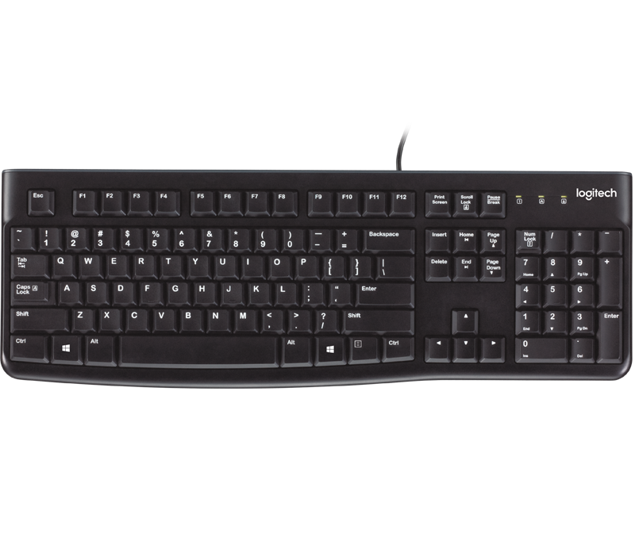

Figure 2.1 Keyboard (REF : PCMag.com)

* Pointing Devices:

Pointing devices are used to input data by movement. They are usually used to operate with screen or movement based information, all of them are manually used so easy to manipulate due to simple movement, like the mouse who just consist of pointing and clicking.

One of the main disadvantages is that they are limited in task, mouse and joystick means that are limited in the work, and touch screen can be less responsive compared to keyboard.

* Optical Devices:

Optical devices are mostly used in recognition or video and image capture, in the field of recognition there is the OMR (optical mark recognition) and the OCR (optical character recognition), and many others.

The OMR reader is used in barcode reader, it scan a mark which indicate the data or information input that is send to the computer to be processed, it is also used in face recognition, finger print scanner, retina scanner and so on. The OCR is for text and character recognition when scanning a text document.

Basically, optical devices are faster than other devices because of a high-speed reading, and are more used by security mean due to their accuracy and reliability.

The disadvantage lies in the raw data, for instance if there is a single change in it, the optical devices may not recognize and there for give a wrong output to its user

* Audio Devices:

Audio devices like his name indicate, is mainly to input an audio data. It allows a user to send audio signals to a computer for processing, recording, or carrying out commands, sometimes the main purpose is to transfer input audio to output audio.

The disadvantage is if the source of audio have a bad signals then all the process are wrong.

1. Output Device

Output device is a peripheral and hardware device used to receive the result of the processing date that comes from its input. All computer or information system absolutely need output devices.

There are three principal types of output devices based on the way they deliver the output data :

* Display Output:

They are commonly monitors, screen or light based devices called Visual Display Unit (VDU). It is the primary output devices and it can also be used as a input device, the computer will display the contents of the information on the screen to permit the users read or see what are the processes done to the input data, that is called soft copy which mean temporary data copy.

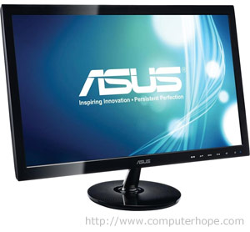

Figure 2.2 Visual Display Unit (REF : computerhope.com)

Display output devices is also the wall between computer-language and human-language, without it human can't understand what the computer try to communicate.

The advantages of display device is that people can see the output of a computer program and also use the computer easily by giving it commands from a Command Line Interface or use the Pointing device such as Mouse to point and click to do a task from a Graphical User Interface (GUI).

In another hand, disadvantages are that the output is temporary because of the need of power supply and can cause visual problem for users.

* Physical Output:

Physical output or hard copy is the permanent output; the most common way to get it is the printer.

* Audio Output:

Audio output devices refer to any devices that are attaches to a computer for the purpose of playing sound, such as speech or music. It can also refer to the sound of a computer sound card.

There are no real disadvantages for audio output devices, just it need some additional hardware such as sound card and additional power supply, and the possibility of making noise.

1. System Unit

Alternatively referred to as a box or the main unit, a system unit is the case that contains all of the main parts of a computer. Below is a picture of a computer with each of the main components that help make up a computer. In the picture, the user can see the system unit, [Flat-panel display](https://www.computerhope.com/jargon/f/fpdispla.htm), [Speakers](https://www.computerhope.com/jargon/s/speaker.htm), [Keyboard](https://www.computerhope.com/jargon/k/keyboard.htm), and [Mouse](https://www.computerhope.com/jargon/m/mouse.htm). The figure is also labeled each of the [input devices](https://www.computerhope.com/jargon/i/inputdev.htm) and [output devices](https://www.computerhope.com/jargon/o/outputde.htm).

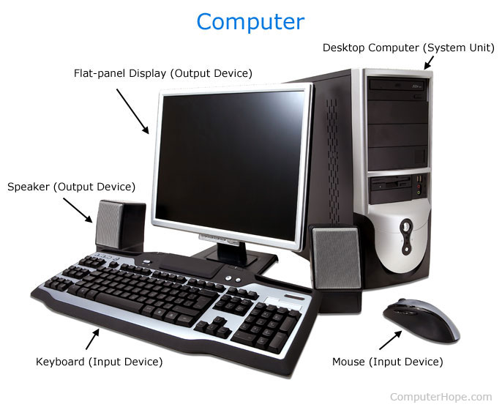

Figure 2.3 The main components of computer (REF : ComputerHope.com)

1. Storage Devices:

There are primarily three types of storage a computer possess, first the primary storage, which is more popularly called simply memory; the secondary storage, which is more popularly referred to as simply storage, and finally the offline storage referred as movable storage.

Types of storage a computer possess are:

* Primary Storage

Primary storage is where a computer stores data on a temporary basis so it can process the data. Think of primary storage as "short term memory". Primary storage is a type of memory that is directly accessible to a computer processor and it is volatile because it is temporary in nature and is erased when the power is turned off.

The main primary storages are:

* RAM (Random Access Memory)
* ROM (Read Only Memory)

Data the computer is currently processing or data which the computer knows it is about to need for processing is stored in primary storage. Memory in primary storage can be accessed quickly by the CPU. Its storage capacity, however, is much smaller than what can be stored in secondary or tertiary storage. Computers need just enough primary storage to function and temporarily hold anticipated amounts of data for processing.

* Secondary Storage:

Secondary storage is where a computer stores data it is not currently processing but which it may need at some later time. Secondary storage can be thought of as "long term memory", or storage, and it is non-volatile in nature because data remains intact even when power to a computer is turned off. Operating systems, documents, music files and so on are typically stored in a secondary storage device. They can also be external for movement and transport.

The main device for secondary storage is the hard disk drive (HDD). The computer's largest secondary storage location is its hard disk drive, or just hard drive. Hard drives are platters like dishes which are stacked top, middle, and bottom to make one unit. Hard drives are mechanical devices which store data magnetically. They are considered permanent storage.

Among the advantages of a hard disk drive is its storage capability, from Megabyte to Terabyte. Hard disk drives are durable, with metal casings built around their inner components. Hard disk drives are read/write. They can be read over and over and they can be modified, or written to, over and over.

* Offline storage:

Offline storage is storage media which can be inserted into the computer and used but which can then be removed from the computer and stored elsewhere. It can also be external sources which are connected to the computer and then disconnected, like floppy drives, CD drives, DVD drives, USB flash drive, and Blu-ray drives.

## Software Definition

Computer software, or simply software, is a part of a [computer system](https://en.wikipedia.org/wiki/Computer_system) that consists of [data](https://en.wikipedia.org/wiki/Data_(computing)) or computer instructions, in contrast to the [physical hardware](https://en.wikipedia.org/wiki/Computer_hardware) from which the system is built. In [computer science](https://en.wikipedia.org/wiki/Computer_science) and [software engineering](https://en.wikipedia.org/wiki/Software_engineering), computer software is all [information](https://en.wikipedia.org/wiki/Information) processed by [computer systems](https://en.wikipedia.org/wiki/Computer_system), [programs](https://en.wikipedia.org/wiki/Computer_program) and data. Computer software includes [computer programs](https://en.wikipedia.org/wiki/Computer_program), [libraries](https://en.wikipedia.org/wiki/Library_(computing)) and related non-executable [data](https://en.wikipedia.org/wiki/Data_(computing)), such as [online documentation](https://en.wikipedia.org/wiki/Software_documentation) or [digital media](https://en.wikipedia.org/wiki/Digital_media). Computer hardware and software require each other and neither can be realistically used on its own.

1. System Software

System software is a type of computer [program](http://searchsoftwarequality.techtarget.com/definition/program) that is designed to run a computer’s hardware and [application programs](http://searchsoftwarequality.techtarget.com/definition/application-program).

The operating system ([OS](http://searchcio-midmarket.techtarget.com/definition/operating-system)) is the best-known example of system software. The OS manages all the other programs in a computer.

Other examples of system software and what each does:

* The [BIOS](http://whatis.techtarget.com/definition/BIOS-basic-input-output-system) (basic input/output system) gets the computer system started after it turned on and manages the data flow between the operating system and attached devices such as the [hard disk](http://searchstorage.techtarget.com/definition/hard-disk), [video adapter](http://searchcio-midmarket.techtarget.com/definition/video-adapter), [keyboard](http://searchcio-midmarket.techtarget.com/definition/keyboard), [mouse](http://searchexchange.techtarget.com/definition/mouse), and [printer](http://whatis.techtarget.com/definition/printer).
* The [boot](http://searchwinit.techtarget.com/definition/boot) program loads the operating system into the computer's main memory or random access memory ([RAM](http://searchmobilecomputing.techtarget.com/definition/RAM)).
* An [assembler](http://searchdatacenter.techtarget.com/definition/assembler) takes basic computer [instructions](http://searchcio-midmarket.techtarget.com/definition/instruction) and converts them into a pattern of [bit](http://searchcio-midmarket.techtarget.com/definition/bit)s that the computer's [processor](http://searchcio-midmarket.techtarget.com/definition/processor) can use to perform its basic operations.
* A [device driver](http://searchenterprisedesktop.techtarget.com/definition/device-driver) controls a particular type of [device](http://whatis.techtarget.com/definition/device) that is attached to a computer, such as a keyboard or a mouse. The driver program converts the more general input/output instructions of the operating system to messages that the device type can understand.

1. Application Software

An application program (app or application for short) is a [computer program](https://en.wikipedia.org/wiki/Computer_program) designed to perform a group of coordinated functions, tasks, or activities for the benefit of the user. Examples of an application include a [word processor](https://en.wikipedia.org/wiki/Word_processor), a [spreadsheet](https://en.wikipedia.org/wiki/Spreadsheet), an [accounting application](https://en.wikipedia.org/wiki/Accounting_software), a [web browser](https://en.wikipedia.org/wiki/Web_browser), a [media player](https://en.wikipedia.org/wiki/Media_player_(application_software)), an aeronautical [flight simulator](https://en.wikipedia.org/wiki/Flight_simulator), a [console game](https://en.wikipedia.org/wiki/Console_game) or a [photo editor](https://en.wikipedia.org/wiki/Photo_editor).

Table 2.1 Application Software (REF : Wikipedia)

|  |  |
| --- | --- |
| **Application Software Type** | **Examples** |
| Word processing software | MS Word, WordPad and Notepad |
| Database software | Oracle, MS Access etc |
| Spreadsheet software | Apple Numbers, Microsoft Excel |
| Multimedia software | Real Player, Media Player |
| Presentation Software | Microsoft Power Point, Keynotes |
| Information Worker Software | Documentation tools, resource management tools |
| Educational Software | Dictionaries: Encarta, Britannica Mathematical: MATLAB Others: Google Earth, NASA World Wind |
| Simulation Software | Flight and scientific simulators |
| Content Access Software | Accessing content through media players, web browsers |
| Application Suites | Open Office, Microsoft Office |
| Software for Engineering and Product Development | IDE or Integrated Development Environments |

* + 1. Utility Software

Utility software helps to manage, maintain and control computer resources. Operating systems typically contain the necessary tools for this, but separate utility programs can provide improved functionality. Utility software is often somewhat technical and targeted at users with a solid knowledge of computers. If the computer used mostly for e-mail, some Internet browsing and typing up a report, the user may not have much need for these utilities. However, if users are an avid computer user, these utilities can help make sure the computer stays in tip-top shape.

## Introduction to Network

A network can be characterized by its physical capacity or its organizational purpose. Use of the network, including user authorization and access rights, differ accordingly.

The characterized network by its area such as:

* 1. **LAN**(Local Area Network)

A **LAN**(local area network) is a group of computers and network devices connected together, usually within the same building. By definition, the connections must be high speed and relatively inexpensive (e.g., token ring or Ethernet). Most Indiana University Bloomington departments are on LANs.

A LAN connection is a high-speed connection to a LAN. On the IUB campus, most connections are either Ethernet (10 Mbps) or Fast Ethernet (100 Mbps), and a few locations have Gigabit Ethernet (1000 Mbps) connections.

* 1. **MAN** (Metropolitan Area Network)

A **MAN** (metropolitan area network) is a larger network that usually spans several buildings in the same city or town. The IUB network is an example of a MAN.

* 1. **WAN** (Wide Area Network)

A **WAN** (wide area network), in comparison to a MAN, is not restricted to a geographical location, although it might be confined within the bounds of a state or country. A WAN connects several LANs, and may be limited to an enterprise (a corporation or an organization) or accessible to the public. The technology is high speed and relatively expensive. The Internet is an example of a worldwide public WAN.

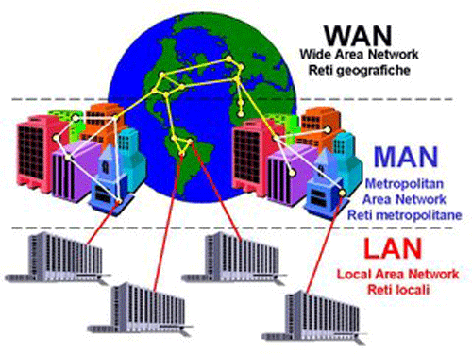

**Figure 2.4 The example of LAN, MAN, WAN (REF : TutorialKomputerdanJaringan.com)**

## Network Architecture

Network architecture is the design of a [communication network](https://en.wikipedia.org/wiki/Communication_network). It is a framework for the specification of a network's [physical components](https://en.wikipedia.org/wiki/Physical_layer) and their functional organization and configuration, its operational principles and procedures, as well as [data formats](https://en.wikipedia.org/wiki/Data_type) use.

Type of Network Architecture are :

1. Client Server

The client–server model is a [distributed application](https://en.wikipedia.org/wiki/Distributed_application) structure that partitions tasks or workloads between the providers of a resource or service, called [servers](https://en.wikipedia.org/wiki/Server_(computing)), and service requesters, called [clients](https://en.wikipedia.org/wiki/Client_(computing)). Often clients and servers communicate over a [computer network](https://en.wikipedia.org/wiki/Computer_network) on separate hardware, but both client and server may reside in the same system. A server [host](https://en.wikipedia.org/wiki/Host_(network)) runs one or more server programs which share their resources with clients. A client does not share any of its resources, but requests a server's content or service function. Clients therefore initiate communication sessions with servers which await incoming requests. Examples of computer applications that use the client–server model are [Email](https://en.wikipedia.org/wiki/Email), [network printing](https://en.wikipedia.org/wiki/Network_printing), and the [World Wide Web](https://en.wikipedia.org/wiki/World_Wide_Web).

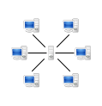

Figure 2.5 Client Server Design (REF : Wikipedia)

1. Peer to Peer

Peer-to-peer (P2P) computing or networking is a distributed application architecture that partitions tasks or workloads between peers. Peers are equally privileged, equipotent participants in the application. They are said to form a peer-to-peer network of nodes.

Peers make a portion of their resources, such as processing power, disk storage or network bandwidth, directly available to other network participants, without the need for central coordination by servers or stable hosts. Peers are both suppliers and consumers of resources, in contrast to the traditional [client-server](https://en.wikipedia.org/wiki/Client-server) model in which the consumption and supply of resources is divided. Emerging collaborative P2P systems are going beyond the era of peers doing similar things while sharing resources, and are looking for diverse peers that can bring in unique resources and capabilities to a virtual community thereby empowering it to engage in greater tasks beyond those that can be accomplished by individual peers, yet that are beneficial to all the peers.

While P2P systems had previously been used in many application domains, the architecture was popularized by the file sharing system [Napster](https://en.wikipedia.org/wiki/Napster), originally released in 1999. The concept has inspired new structures and philosophies in many areas of human interaction. In such social contexts, [peer-to-peer as a meme](https://en.wikipedia.org/wiki/Peer-to-peer_(meme)) refers to the [egalitarian](https://en.wikipedia.org/wiki/Egalitarianism) [social networking](https://en.wikipedia.org/wiki/Social_network) that has emerged throughout society, enabled by [Internet](https://en.wikipedia.org/wiki/Internet) technologies in general.

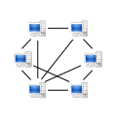

Figure 2.6 Peer to Peer Design (REF : Wikipedia)

1. Hybrid

A Hybrid architecture is a combination of two network, peer to peer and client server. This model architecture is a quite complex architecture computer network.

1. **Network Topology**

A network topology is the arrangement of a network, including its nodes and connecting lines. There are two ways of defining network geometry: the physical topology and the logical (or signal) topology.

The physical topology of a network is the actual geometric layout of workstations. There are several common physical topologies, as described below and as shown in the illustration.

* In the [bus network](http://searchnetworking.techtarget.com/definition/bus-network) topology, every [workstation](http://searchmobilecomputing.techtarget.com/definition/workstation) is connected to a main cable called the [bus](http://searchstorage.techtarget.com/definition/bus). Therefore, in effect, each workstation is directly connected to every other workstation in the network.
* In the [star network](http://searchnetworking.techtarget.com/definition/star-network) topology, there is a central computer or server to which all the workstations are directly connected. Every workstation is indirectly connected to every other through the central computer.
* In the [ring network](http://searchcio-midmarket.techtarget.com/definition/ring-network) topology, the workstations are connected in a closed loop configuration. Adjacent pairs of workstations are directly connected. Other pairs of workstations are indirectly connected, the data passing through one or more intermediate nodes.

If a [Token Ring](http://searchnetworking.techtarget.com/definition/Token-Ring) protocol is used in a star or ring topology, the signal travels in only one direction, carried by a so-called [token](http://whatis.techtarget.com/definition/token) from node to node.

* The [mesh network](http://searchnetworking.techtarget.com/definition/mesh-network) topology employs either of two schemes, called full mesh and partial mesh. In the full mesh topology, each workstation is connected directly to each of the others. In the partial mesh topology, some workstations are connected to all the others, and some are connected only to those other nodes with which they exchange the most data.
* The [tree network](http://searchnetworking.techtarget.com/definition/tree-network) topology uses two or more star networks connected together. The central computers of the star networks are connected to a main bus. Thus, a tree network is a bus network of star networks.

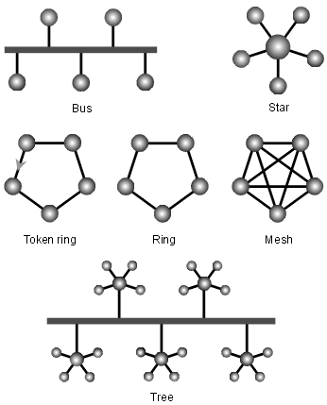

Figure 2.7 Geometric layout of workstations of Network Topology (REF : Wikipedia)

Logical (or signal) topology refers to the nature of the paths the signals follow from node to node. In many instances, the logical topology is the same as the physical topology. But this is not always the case. For example, some networks are physically laid out in a star configuration, but they operate logically as bus or ring networks.

## Identifying Computer on a Network

The Computer had an unique address in the systems which allows other computer to detect the Computer unit in a specified location in the network systems. This Addresses using numerical label for communication over internet or private networks.

1. IP Address

An Internet Protocol address (IP address) is a numerical label assigned to each device connected to a [computer network](https://en.wikipedia.org/wiki/Computer_network) that uses the [Internet Protocol](https://en.wikipedia.org/wiki/Internet_Protocol) for communication. An IP address serves two principal functions: host or network interface [identification](https://en.wikipedia.org/wiki/Identification_(information)) and location [addressing](https://en.wikipedia.org/wiki/Network_address).

[Version 4 of the Internet Protocol](https://en.wikipedia.org/wiki/IPv4) (IPv4) defines an IP address as a [32-bit](https://en.wikipedia.org/wiki/32-bit) number. However, because of the growth of the Internet and the [depletion of available IPv4 addresses](https://en.wikipedia.org/wiki/IPv4_address_exhaustion), a new version of IP ([IPv6](https://en.wikipedia.org/wiki/IPv6)), using 128 bits for the IP address, was developed in 1995, and standardized as [RFC 2460](https://tools.ietf.org/html/rfc2460)in 1998. [IPv6 deployment](https://en.wikipedia.org/wiki/IPv6_deployment) has been ongoing since the mid-2000s.

IP addresses are usually written and displayed in [human-readable](https://en.wikipedia.org/wiki/Human-readable) notations, such as 172.16.254.1 in IPv4, and 2001:db8:0:1234:0:567:8:1 in IPv6.

The IP address space is managed globally by the [Internet Assigned Numbers Authority](https://en.wikipedia.org/wiki/Internet_Assigned_Numbers_Authority) (IANA), and by five [regional Internet registries](https://en.wikipedia.org/wiki/Regional_Internet_registry) (RIR) responsible in their designated territories for assignment to end users and [local Internet registries](https://en.wikipedia.org/wiki/Local_Internet_registry), such as [Internet service providers](https://en.wikipedia.org/wiki/Internet_service_providers). IPv4 addresses have been distributed by IANA to the RIRs in blocks of approximately 16.8 million addresses each. Each ISP or private network administrator assigns an IP address to each device connected to its network. Such assignments may be on a *static* (fixed or permanent) or *dynamic* basis, depending on its software and practices.

With an IPv4 IP address, there are five classes of available IP ranges: Class A, Class B, Class C, Class D and Class E, while only A, B, and C are commonly used. Each class allows for a range of valid IP addresses, shown in the following table.

Table 2.2 Classes of IP Address (REF : ComputerHope.com)

|  |  |  |
| --- | --- | --- |
| **Class** | **Address Range** | **Supports** |
| **Class A** | 1.0.0.1 to 126.255.255.254 | Supports 16 million hosts on each of 127 networks. |
| **Class B** | 128.1.0.1 to 191.255.255.254 | Supports 65,000 hosts on each of 16,000 networks. |
| **Class C** | 192.0.1.1 to 223.255.254.254 | Supports 254 hosts on each of 2 million networks. |
| **Class D** | 224.0.0.0 to 239.255.255.255 | Reserved for [multicast](https://www.computerhope.com/jargon/m/multicast.htm) groups. |
| **Class E** | 240.0.0.0 to 254.255.255.254 | Reserved for future use, or Research and Development Purposes. |

1. MAC Address

A media access control address (MAC address) of a computer is a [unique identifier](https://en.wikipedia.org/wiki/Unique_identifier) assigned to [network interfaces](https://en.wikipedia.org/wiki/Network_interface_controller) for communications at the [data link layer](https://en.wikipedia.org/wiki/Data_link_layer) of a network segment. MAC addresses are used as a [network address](https://en.wikipedia.org/wiki/Network_address) for most [IEEE 802](https://en.wikipedia.org/wiki/IEEE_802) network technologies, including [Ethernet](https://en.wikipedia.org/wiki/Ethernet) and [Wi-Fi](https://en.wikipedia.org/wiki/Wi-Fi). Logically, MAC addresses are used in the [media access control](https://en.wikipedia.org/wiki/Media_access_control) protocol sub layer of the [OSI reference model](https://en.wikipedia.org/wiki/OSI_model).

MAC addresses are most often assigned by the manufacturer of a [network interface controller](https://en.wikipedia.org/wiki/Network_interface_controller) (NIC) and are stored in its hardware, such as the card's [read-only memory](https://en.wikipedia.org/wiki/Read-only_memory) or some other [firmware](https://en.wikipedia.org/wiki/Firmware) mechanism. If assigned by the manufacturer, a MAC address usually encodes the manufacturer's registered identification number and may be referred to as the burned-in address (BIA). It may also be known as an Ethernet hardware address (EHA), hardware address or *physical address* (not to be confused with a [memory physical address](https://en.wikipedia.org/wiki/Physical_address)). This can be contrasted to a programmed address, where the host device issues commands to the NIC to use an arbitrary address.

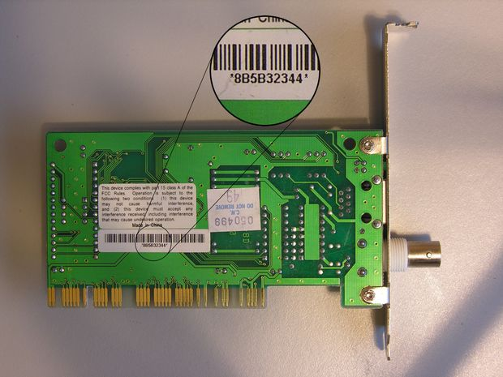

Figure 2.8 MAC Address (REF : cdn.instructables.com)

Functions of Mac Address such as :

* MAC addresses are the low level basics that make the ethernet based network work.
* Network cards each have a unique MAC address. Packets that are sent on the ethernet are always coming from a MAC address and sent to a MAC address. If a network adapter is receiving a packet, it is comparing the packet’s destination MAC address to the adapter’s own MAC address. If the addresses match, the packet is processed, otherwise it is discarded.

## ****Network Media****

Network Media is the physical matter or substance that carries the voice or data transmission. Many different types of transmission media are currently in use, such as copper (wire), glass or plastic (fiber-optic cable), or air (radio, infrared, microwave, or satellite). There are two basic types of media. Wired are those in which the message flows through a physical media such as a twisted-pair wire, coaxial cable, or fiber-optic cable. Wireless media are those in which the message is broadcast through the air, such as infrared, microwave, or satellite. In the [OSI model](https://en.wikipedia.org/wiki/OSI_model), these are defined at layers 1 and 2 — the physical layer and the data link layer.

A widely adopted family of transmission media used in local area network ([LAN](https://en.wikipedia.org/wiki/LAN)) technology is collectively known as [Ethernet](https://en.wikipedia.org/wiki/Ethernet). The media and protocol standards that enable communication between networked devices over Ethernet are defined by [IEEE 802.3](https://en.wikipedia.org/wiki/IEEE_802.3). Ethernet transmits data over both copper and fiber cables. Wireless LAN standards (e.g. those defined by [IEEE 802.11](https://en.wikipedia.org/wiki/IEEE_802.11)) use [radio waves](https://en.wikipedia.org/wiki/Radio_waves), or others use [infrared](https://en.wikipedia.org/wiki/IrDA) signals as a transmission medium. [Power line communication](https://en.wikipedia.org/wiki/Power_line_communication) uses a building's power cabling to transmit data.

Basic types of network media are :

1. Wired Network

A wired [network](https://techterms.com/definition/network) is a common type of wired configuration. Most wired networks use [Ethernet](https://techterms.com/definition/ethernet) cables to transfer data between connected [PCs](https://techterms.com/definition/pc). Distrubance in the data transmission caused due to generation of electro-magnetic radiation are called Electro-magnetic Interference (EMII).

The orders of the following wired technologies are, roughly, from slowest to fastest transmission speed.

* [*Coaxial cable*](https://en.wikipedia.org/wiki/Coaxial_cable) is widely used for cable television systems, office buildings, and other work-sites for local area networks. The cables consist of copper or aluminum wire surrounded by an insulating layer (typically a flexible material with a high dielectric constant), which itself is surrounded by a conductive layer. The insulation helps minimize interference and distortion. Transmission speed ranges from 200 million bits per second to more than 500 million bits per second.

[ITU-T](https://en.wikipedia.org/wiki/ITU-T) [G.hn](https://en.wikipedia.org/wiki/G.hn) technology uses existing [home wiring](https://en.wikipedia.org/wiki/Home_wiring) ([coaxial cable](https://en.wikipedia.org/wiki/Ethernet_over_coax), phone lines and [power lines](https://en.wikipedia.org/wiki/Power_line_communication)) to create a high-speed (up to 1 Gigabit/s) local area network

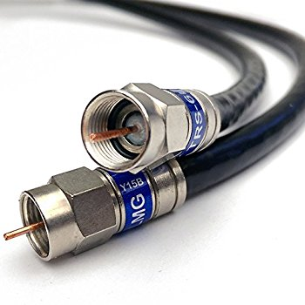

Figure 2.9 Coaxial Cable (REF : images-na.ssl-images-amazon.com)

* [*Twisted pair*](https://en.wikipedia.org/wiki/Twisted_pair)*wire* is the most widely used medium for all telecommunication. Twisted-pair cabling consist of copper wires that are twisted into pairs. Ordinary telephone wires consist of two insulated copper wires twisted into pairs. Computer network cabling (wired [Ethernet](https://en.wikipedia.org/wiki/Ethernet) as defined by [IEEE 802.3](https://en.wikipedia.org/wiki/IEEE_802.3)) consists of 4 pairs of copper cabling that can be utilized for both voice and data transmission. The use of two wires twisted together helps to reduce [crosstalk](https://en.wikipedia.org/wiki/Crosstalk_(electronics)) and [electromagnetic induction](https://en.wikipedia.org/wiki/Electromagnetic_induction). The transmission speed ranges from 2 million bits per second to 10 billion bits per second. Twisted pair cabling comes in two forms: unshielded twisted pair (UTP) and shielded twisted-pair (STP). Each form comes in several category ratings, designed for use in various scenarios.

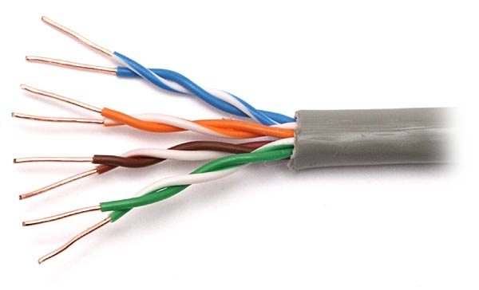

Figure 2.10 [Twisted pair](https://en.wikipedia.org/wiki/Twisted_pair) (REF : qph.ec.quoracdn.net)

* An [*optical fiber*](https://en.wikipedia.org/wiki/Optical_fiber) is a glass fiber. It carries pulses of light that represent data. Some advantages of optical fibers over metal wires are very low transmission loss and immunity from electrical interference. Optical fibers can simultaneously carry multiple wavelengths of light, which greatly increases the rate that data can be sent, and helps enable data rates of up to trillions of bits per second. Optic fibers can be used for long runs of cable carrying very high data rates, and are used for [undersea cables](https://en.wikipedia.org/wiki/Undersea_cables) to interconnect continents.

1. Wireless Network

A wireless network is a [computer network](https://en.wikipedia.org/wiki/Computer_network) that uses wireless data connections between [network nodes](https://en.wikipedia.org/wiki/Network_node). Wireless networking is a method by which homes, [telecommunications networks](https://en.wikipedia.org/wiki/Telecommunications_network) and business installations avoid the costly process of introducing cables into a building, or as a connection between various equipment locations [Wireless](https://en.wikipedia.org/wiki/Wireless) telecommunications networks are generally implemented and administered using [radio communication](https://en.wikipedia.org/wiki/Radio_communication). This implementation takes place at the physical level (layer) of the [OSI model](https://en.wikipedia.org/wiki/OSI_model) network structure.

The Type of Wireless Network are :

* Terrestrial [microwave](https://en.wikipedia.org/wiki/Microwave) – Terrestrial microwave communication uses Earth-based transmitters and receivers resembling satellite dishes. Terrestrial microwaves are in the low gigahertz range, which limits all communications to line-of-sight. Relay stations are spaced approximately 48 km (30 mi) apart.
* Communications [satellites](https://en.wikipedia.org/wiki/Satellite) – Satellites communicate via microwave radio waves, which are not deflected by the Earth's atmosphere. The satellites are stationed in space, typically in geosynchronous orbit 35,400 km (22,000 mi) above the equator. These Earth-orbiting systems are capable of receiving and relaying voice, data, and TV signals.
* [Cellular](https://en.wikipedia.org/wiki/Cellular_network) and PCS systems use several radio communications technologies. The systems divide the region covered into multiple geographic areas. Each area has a low-power transmitter or radio relay antenna device to relay calls from one area to the next area.
* Radio and [spread spectrum](https://en.wikipedia.org/wiki/Spread_spectrum) technologies – Wireless local area networks use a high-frequency radio technology similar to digital cellular and a low-frequency radio technology. Wireless LANs use spread spectrum technology to enable communication between multiple devices in a limited area. [IEEE 802.11](https://en.wikipedia.org/wiki/IEEE_802.11) defines a common flavor of open-standards wireless radio-wave technology known as [Wifi](https://en.wikipedia.org/wiki/Wifi).
* [Free-space optical communication](https://en.wikipedia.org/wiki/Free-space_optical_communication) uses visible or invisible light for communications. In most cases, [line-of-sight propagation](https://en.wikipedia.org/wiki/Line-of-sight_propagation) is used, which limits the physical positioning of communicating devices.

## Network Devices

Apart from any physical transmission media there may be, networks comprise additional basic [system](https://en.wikipedia.org/wiki/Systems_engineering) building blocks, such as [network interface controllers](https://en.wikipedia.org/wiki/Network_interface_controller) (NICs), [repeaters](https://en.wikipedia.org/wiki/Repeater), [hubs](https://en.wikipedia.org/wiki/Ethernet_hub), [bridges](https://en.wikipedia.org/wiki/Network_bridge), [switches](https://en.wikipedia.org/wiki/Network_switch), [routers](https://en.wikipedia.org/wiki/Router_(computing)), [modems](https://en.wikipedia.org/wiki/Modem), and [firewalls](https://en.wikipedia.org/wiki/Firewall_(computing)). Any particular piece of equipment will frequently contain multiple building blocks and perform multiple functions.

* Network interfaces

A [network interface controller](https://en.wikipedia.org/wiki/Network_interface_controller) (NIC) is [computer hardware](https://en.wikipedia.org/wiki/Computer_hardware) that provides a computer with the ability to access the transmission media, and has the ability to process low-level network information. For example, the NIC may have a connector for accepting a cable, or an aerial for wireless transmission and reception, and the associated circuitry.

[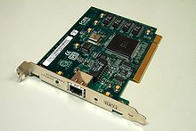](https://en.wikipedia.org/wiki/File:ForeRunnerLE_25_ATM_Network_Interface_(1).jpg)

**Figure 2.11 Network Interfaces (REF : Wikipedia)**

* Bridges

A [network bridge](https://en.wikipedia.org/wiki/Network_bridge) connects and filters traffic between two [network segments](https://en.wikipedia.org/wiki/Network_segment) at the [data link layer](https://en.wikipedia.org/wiki/Data_link_layer) (layer 2) of the [OSI model](https://en.wikipedia.org/wiki/OSI_model) to form a single network. This breaks the network's collision domain but maintains a unified broadcast domain. Network segmentation breaks down a large, congested network into an aggregation of smaller, more efficient networks.

Bridges come in three basic types:

* Local bridges: Directly connect LANs
* Remote bridges: Can be used to create a wide area network (WAN) link between LANs. Remote bridges, where the connecting link is slower than the end networks, largely have been replaced with routers.
* Wireless bridges: Can be used to join LANs or connect remote devices to LANs.
* Switches

A [network switch](https://en.wikipedia.org/wiki/Network_switch) is a device that forwards and filters [OSI layer 2](https://en.wikipedia.org/wiki/OSI_layer_2) [datagrams](https://en.wikipedia.org/wiki/Datagram) ([frames](https://en.wikipedia.org/wiki/Frame_(networking))) between [ports](https://en.wikipedia.org/wiki/Computer_port_(hardware)) based on the destination MAC address in each frame. A switch is distinct from a hub in that it only forwards the frames to the physical ports involved in the communication rather than all ports connected. It can be thought of as a multi-port bridge. It learns to associate physical ports to MAC addresses by examining the source addresses of received frames. If an unknown destination is targeted, the switch broadcasts to all ports but the source. Switches normally have numerous ports, facilitating a star topology for devices, and cascading additional switches.

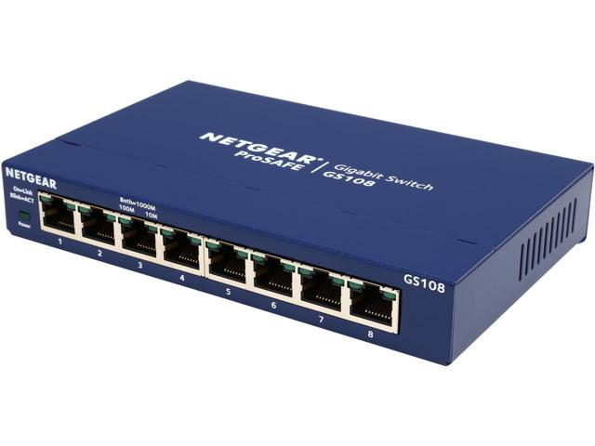

**Figure 2.12 Switch (REF : Newegg.com)**

[Multi-layer switches](https://en.wikipedia.org/wiki/Network_switch#Layer-specific_functionality) are capable of routing based on layer 3 addressing or additional logical levels. The term switch is often used loosely to include devices such as routers and bridges, as well as devices that may distribute traffic based on load or based on application content (e.g., a Web [URL](https://en.wikipedia.org/wiki/Uniform_Resource_Locator) identifier).

* Routers

A typical home or small office router showing the [ADSL](https://en.wikipedia.org/wiki/ADSL) telephone line and [Ethernet](https://en.wikipedia.org/wiki/Ethernet) network cable connections

A [router](https://en.wikipedia.org/wiki/Router_(computing)) is an [internetworking](https://en.wikipedia.org/wiki/Internetworking) device that forwards [packets](https://en.wikipedia.org/wiki/Packet_(information_technology)) between networks by processing the routing information included in the packet or datagram (Internet protocol information from layer 3). The routing information is often processed in conjunction with the routing table (or forwarding table). A router uses its routing table to determine where to forward packets. A destination in a routing table can include a "null" interface, also known as the "black hole" interface because data can go into it, however, no further processing is done for said data, i.e. the packets are dropped.

[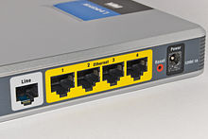](https://en.wikipedia.org/wiki/File:Adsl_connections.jpg)

Figure 2.13 Router (REF : Wikipedia)

* Modems

[Modems](https://en.wikipedia.org/wiki/Modem) (MOdulator-DEModulator) are used to connect network nodes via wire not originally designed for digital network traffic, or for wireless. To do this one or more [carrier signals](https://en.wikipedia.org/wiki/Carrier_signal) are [modulated](https://en.wikipedia.org/wiki/Modulation) by the digital signal to produce an [analog signal](https://en.wikipedia.org/wiki/Analog_signal) that can be tailored to give the required properties for transmission. Modems are commonly used for telephone lines, using a [Digital Subscriber Line](https://en.wikipedia.org/wiki/Digital_Subscriber_Line) technology.

* Firewalls

A [firewall](https://en.wikipedia.org/wiki/Firewall_(computing)) is a network device for controlling network security and access rules. Firewalls are typically configured to reject access requests from unrecognized sources while allowing actions from recognized ones. The vital role firewalls play in network security grows in parallel with the constant increase in [cyber attacks](https://en.wikipedia.org/wiki/Cyberattack).

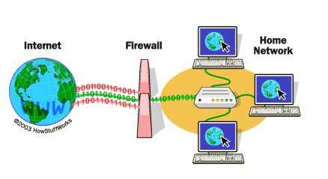

**Figure 2.14 Firewalls Example (REF : Comodo)**

## Network Operating System

Network Operating System enable sharing of information and resource based on the accessibility privilege allocated to each user or device in the network.

Example of Network Operating System are :

1. Windows Server 2012

Is a server network operating system edition of the windows 8 os.

Comprises the following edition:

* Datacenter Edition
* Standard Edition
* Foundation Edition
* Essentials Edition

1. Unix

Unix Operating System is one of the earliest and most widely used network Operating Systems lauched by Bell Labs. It provides internet – based services and provides network security. Unix compatible with different protocol.

1. Linux

Linux is an open source OS developed by Linux Torvalds . It’s provides flexibility to the user modify the OS according to individual requirement. Linux can be customized and distributed by anyone to meet different business requirement.

1. Solaris

Solaries specifically design for e-commerce applications. It’s anages high-traffic network areas and incorporates security necessary for web transactions and support thousands of user of a time.Solaries is scalable as it can support a single processor to multi-processor System. It has utilities that are portable to all the platforms supported by Solaris.

# CHAPTER III : PROBLEM ANALYSIS

## Analysis

To configure the Physical Space and the Networking Cyber-environment required a resources in Hardware, Software, LAN, The Architectural Types, Topology, Network Identifier, Wired Networking media, Network Devices, and Network Operating system.

School is a place for formally learn and to educate people in various country. The school accomodates its students to learn the specified or general knowledge. The technological era in which schools had delve into the digitally constructed to simplify the learning and studying process or activity. This facility came accross with the use of computer and network systems. Which allows school to created a specific room for E-learning process.

This room which called a Computer Lab, using the computer for its primary activity during the learning sessions. The computer between computer had configured using Networking System of LAN (Local Area Network) to achieve a communicational interaction between computer functions.

From the analysis, there’s two computer lab and one administrator room. From a lab computer room consist of five computers connected into a switch and one server in a Client-Server architecture. As for the administrator rooms there’s for=ur main computer that connects to the both of computer labs in Peer to Peer Architecture.

1. Abstraction Environment

The School Network System is based on the one building that had 3 rooms Which are The Client Server 1, Client Server 2, and The Administrator Room. The Client Servers is used for Computer Labs, While the Administrator rooms is used for monitor the student, teacher, and learning activity inside Computer Labs. The Administrator room is also responsible for held the resoursce printers, and computer lab saved data.

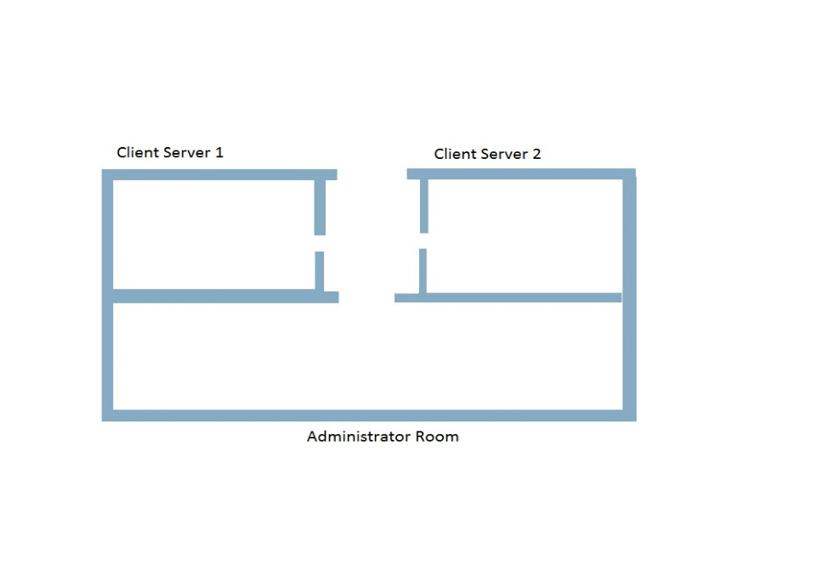

Figure 3.15 The Architectural of rooms (REF : Cisco)

1. The Devices

The Computer labs need computer to operate for students learning activity. Each client computer in both labs need to be connected via Client-Server network. The Server network connected to the administrator room with the P2P Network Architecture which allows the Server requesting the data permission through Administrator’s PC.

The Lab computer 1 & 2 had 10 computer, 2 switch and 2 server in separate room and topology. While the Administrator room had 4 computers, single deskjet printer connected to router and connect to the client server network via hub.

## Network Design

1. Networking Topology

A network topology is the arrangement of a network, including its nodes and connecting lines. The school use the following of network topology, such as :

* Star Topology

Star used in the client server system that existed in the Computer Lab 1 and 2. The Function of star is more effective because when the cable was cut off from the connection, the other line can still operates.

* Peer To Peer Topology

The Peer to Peer Network system is created to connect the both Server in Computer Labs and Administrator Room. The use of this topology is to achieve the independent computer in Administrator personal Workstations. Which each of the Network Administrator Workstations and Server computer labs could act without restriction from other foreign computer.

## Networking Architecture

1. The Client-Server Architecture.

The client-server architecture is where a main server held as its Server and the other computers held as the Clients.

The Computer Labs that operated in the school is using the client-server architecture, this allows the students to use resoursces that the server provides with the permission from the server and the server could monitor the students activity during study sessions.

1. Peer to peer (P2P)

The peer to peer architecture is where every computer stand as the same hierarchical layer. There’s no distinctive differences between computers.

The Administrator and Lab computer servers are connected with peer to peer. The server could easily communicates to the administrator room without permission from other computer and vice versa. Because the peer to peer had an access to every node from the provided network system.

## Hardware and Software

The school that based on digital technology needs the primary resource which is the computer, the computer is include with the hardware and software that operates well in order to do certain task.

1. Hardware

Table 3.3 The Hardware of School Network (REF : Analysis by group)

|  |  |  |  |
| --- | --- | --- | --- |
| Devices | Hardware | Spec | Function |
| Client Computer | * Monitor * Keyboard * Mouse * CPU | * LG Flatron * Logitech * Logitech * NEC Core 2 duo D21A | * To display GUI * Typing and input button * Cursor and pointer * Central Processor |
| Server | * Monitor * Mini Server * Keyboard * Mouse | * Asus LED HD monitor * Intel NUC5i3RYH Mini PC * Logitech * Logitech | * To display GUI * Storage, retrieve and send computer files and data to other computers * Typing and input button * Cursor and pointer |
| Switch | * D-link Switch | * Cisco SF95D-08-AS | * Central connector for Client server computer Lab |
| Router | * Router | * Mikrotik rb 951Ui-2hnd | * Central connector for peer to peer architecture in Administrator room |
| Hub | * Hub | * TP-Link tl-sf1008d 8ports | * Central connector for Hybrid architecture access for Lab computer server and Administrator PC |
| Administrator PC | * Monitor * Keyboard * Mouse * CPU | * Asus LED HD monitor * Logitech * Logitech * Dell Optiplex 390 | * To display GUI * Typing and input button * Cursor and pointer * Central Processor |
| Printer | * DeskJet Printer | * DeskJet 1112 | * Physical paper output or media device |

1. Software

Table 3.4 The Software of School Network (REF : Analysis by Group)

|  |  |  |  |
| --- | --- | --- | --- |
| Device | Software | Spec | Functions |
| Client computer | * OS * Utility | * Windows 7 pro * Microsoft Anti-virus * Deep Freeze * School ClientManagement Software | * Operates the device software bakground * Prevent computer Virus and malware * Prevent unlisted software to be installed in the device * Client based software to monitor the student activities |
| Server | * OS * NOS * Utility * Network Administrator tool | * Windows 10 pro * Windows server 2016 * Microsoft Anti-virus * School Management software * Wireshark and Zabbix | * Operates the device software bakground * Sharing of information and resources based on the accessibility previlege * Prevent computer Virus and malware * Manage and Monitor the student activity during learning sessions * Monitor the network and manage bandwith that the clients and server used |
| Administrator PC | * OS * Utility * Network Administrator Tools | * Windows 10 pro * Microsoft Anti-virus * Wireshark and Zabbix | * Prevent computer Virus and malware * Prevent computer Virus and malware * Monitor the network and manage bandwith that the Administrator PCs and servers used |

## IP Address

In the previous chapter had been explained about the type and class IP Address. Broadly speaking IP Address is the host address in the network, that the host can send or receive information on the network.

It has been concluded that there are two types of IP Address, IPV4 and IPV6. Inside the School it is IPV4 because the host range within the school network is not as much as IPV6.

In chapter two has also been explained about the class in the IP Address. This school will set the IP Address with DHCP, that is (Dynamic Host Configuration Protocol) which is the client-server protocol used to assign IP address to client automatically. But not all network members should be assigned IPs using the DHCP method. DHCP IP assignments can be applied to clients, but it is not recommended to use such methods for the granting of IP to devices such as routers, gateways, and servers

Table 3.5 IP Address of Computer Lab 1 (REF : Analysis by Group)

|  |
| --- |
| Computer Lab 1 DHCP Pool |
| IP Address: 192.168.20.1 – 192.168.20.5 |

Table 3.6 IP Address of Computer Lab 2 (REF : Analysis by Group)

|  |
| --- |
| Computer Lab 2 DHCP Pool |
| IP Address: 192.168.20.6 – 192.168.20.10 |

Table 3.7 IP Address of Computer Server (REF : Analysis by Group)

|  |
| --- |
| Computer Lab static server address |
| Server 1 IP address: 192.168.88.10 |
| Server 2 IP address: 192.168.77.10 |

Table 3.8 IP Address of Administrator PC (REF : Analysis by Group)

|  |
| --- |
| Administrator PC |
| PC 6 : 192.177.90.1 |
| PC 7: 192.177.91.1 |
| PC 8: 192.177.92.1 |

Table 3.9 Router Fast Ethernet of School Network (REF : Analysis by Group)

|  |
| --- |
| Router Fast Ethernet |
| FE0/0: 193.168.1.13/24 |
| FE1/0: 193.168.12.21/24 |
| FE2/0: 193.168.22.3/24 |

## Network Media

The school network system is using the wired media in order to maintain the stability of connection in LAN. The more effective way rather than to establish the wireless connection with such undisputed connection bandwidth broadband in one building.

The wiring used for connecting School network is Twisted Pair Cables. The School use it because more economical and easy to setup for network transmission than the other cable. Twisted Pair Cable has 2 type for connecting the devices, such as :

* Copper Straight through

Straight-through cable is used to connect computers and other end-user devices (e.g., printers) to networking devices such as [hubs](http://www.linfo.org/hub.html) and switches. It can also be used to directly connect like devices (e.g., two hubs or two switches) if the cable is plugged into an [uplink port](http://www.linfo.org/uplink_port.html) on one (but not both) of the devices.

* Copper Cross Over

Crossover cable is used to connect two like devices without the use of an uplink port.

Table 3.10 Cable Wiring (REF : Analysis by Group)

|  |  |
| --- | --- |
| CABLE WIRING | SPECIFICATIONS |
| Copper straight through | CAT6A RJ-45 |
| Copper cross-over | CAT5e cliptec RJ-45 |

## Network Operating System

Network operating system is used to allow [shared file and printer access](https://en.wikipedia.org/wiki/Shared_file_access) among multiple computers in a network, to enable the sharing of data, users, groups, security, applications, and other networking functions.

The NOS that used is windows server 2016.

More faster, efficient, and secure. The server is already built without command prompt or CLI config. Faster than to set the line-by-line command section. Easier to deploy modules (web server, Mail server, or VPN). The security is also already built and getting updated by windows itself. To the administrator the server is best to work on right away.

## Network System Map

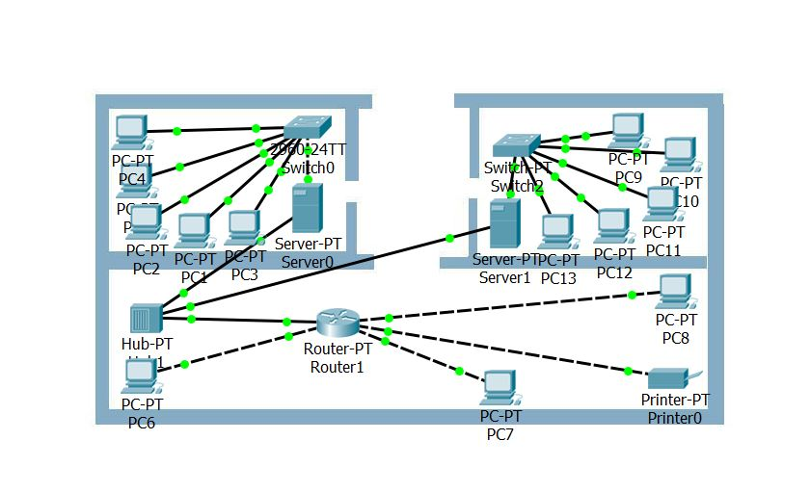

Figure 3.16 Network System Map of LAB 1 (REF : Analysis by Group)



Figure 3.17 Network System Map of LAB 2 (REF : Analysis by Group)

The computer Lab 1 and 2 are using the client-server system that connected by the switch and act as a connector for client computer networking system.

## 

Figure 3.18 Network System Map of Administrator Room (REF : Analysis by Group)

The Administrator room works in peer to peer architectural that connected with the server device in the client-server computer labs. Which allows the computer to sharing resources from administrator to client server.

## Budgeting

1. Hardware

Table 3.11 Budgeting of The Hardware (REF : Analysis by Group)

|  |  |  |  |  |
| --- | --- | --- | --- | --- |
| **Devices** | **Spec** | **Price** | **Quantity** | **Total** |
| **Computer**  -Monitor  -Keyboard  -Mouse  -CPU | * LG Flatron * Logitech * Logitech * NEC Core 2 duo D21A | 1.700.000 | 10 | 17.000.000 |
| **Server**  -Keyboard  -Monitor  -Mouse  -Mini Server | * Asus LED HD monitor * Intel NUC5i3RYH Mini PC * Logitech * Logitech | 8.400.000 | 2 | 17.200.000 |
| Switch | * Cisco SF95D-08-AS | 400.000 | 2 | 800.000 |
| Router | * Mikrotik rb 951Ui-2hnd | 800.000 | 1 | 800.000 |
| HUB | * TP-Link tl-sf1008d 8ports | 80.000 | 1 | 80.000 |
| Printer | * Deskjet 1112 | 500.000 | 1 | 500.000 |
| Administrator PC  -keyboard  -monitor  -mouse  -CPU | * Asus LED HD monitor * Logitech * Logitech * Dell Optiplex 390 | 4.200.000 | 3 | 12.600.000 |
| **Total Budget** | | | | 48.350.000 |

Table 3.12 Badgeting of Wiring Cable (REF : Analysis by Group)

|  |  |  |
| --- | --- | --- |
| CABLE WIRING | SPECIFICATIONS | PRICE |
| Copper straight through | CAT6A RJ-45 250m | Rp. 2.750.000 |
| Copper cross-over | CAT5e cliptec RJ-45 175m | Rp. 2.300.000 |
| Total | | 4.050.000 |

1. Software

Table 3.13 The Software of School Network (REF : Analysis by Group)

|  |  |  |  |  |
| --- | --- | --- | --- | --- |
| Device | Software | Spec | Price | Total |
| Client computer | * OS * Utility | * Windows 7 pro   Microsoft Office   * Microsoft Anti-virus   Chrome   * Deep Freeze * School Client Management Software | * Rp. 2.500.000 * Rp. 300.000 * Rp. 200.000 * Rp. 250.000 * Rp. 250.000 | * Rp. 3.500.000 |
| Server | * OS * NOS * Utility * Network Administrator tool | * Windows 10 pro * Windows server 2016 * Microsoft Anti-virus * School Management software * Wireshark and Zabbix | * Rp. 4.000.000 * Rp. 350.000 * Rp. 200.000 * Rp. 250.000   - | * Rp. 4.800.000 |
| Administrator PC | * OS * Utility * Network Administrator Tools | * Windows 10 pro * Microsoft Anti-virus * Wireshark and Zabbix | * Rp. 4.000.000 * Rp. 200.000 * - | * Rp. 4.200.000 |
| Total | | | | * Rp. 12.500.000 |

1. Total Budget

School needs budget to built a School Computer Network such as :

Table 3.14 Totab Badget (REF : Analysis by Group)

|  |  |
| --- | --- |
| Name | Total |
| Hardware | Rp. 41.600.000 |
| Software | * Rp. 12.500.000 |
| Total Budget | * Rp. 54.100.000 |

# CHAPTER IV: CONCLUSION AND SUGESSTION

## Conclusion

The Computer based school is an advance breakthrough from the technological era. The technology could provide the better facility for scholar to develop their knowledge. The facility which later termed as computer lab is running in the Networking System and supported with devices and software. The use of this technology is educational school program could boost the students performance during study sessions, or furthermore into extraculicular and softskill activities.

The Network System also applied to create communicational interactive student-teacher environment which made the study sessions more efficient. The teacher could also manage the student files via shared network for purpose of grading and archiving works of scholar.

## Suggestion

The technology needs to be used in educational purposes, and better be maximized in its uses to boots the performance of learning and study. The school should go through the advancement of computer and technology to overcome to obstacle admits from its budget and infrastructure of the responses itself.

# BIBLIOGRAPHY

[www.computerhope.com/jargon/s/system-unit.htm](http://www.computerhope.com/jargon/s/system-unit.htm) (24/09/17)

[www.en.wikipedia.org/wiki/Computer_hardware](http://www.en.wikipedia.org/wiki/Computer_hardware) (21/09/17)

[www.en.wikipedia.org/wiki/Software](http://www.en.wikipedia.org/wiki/Software) (23/09/17)

[www.en.wikipedia.org/wiki/Application_software](http://www.en.wikipedia.org/wiki/Application_software) (21/09/17)

[www.en.wikipedia.org/wiki/Computer_network](http://www.en.wikipedia.org/wiki/Computer_network) (22/09/17)

[www.en.wikipedia.org/wiki/Client–server](http://www.en.wikipedia.org/wiki/Client–server) (26/09/17)

[www.en.wikipedia.org/wiki/Network_architecture](http://www.en.wikipedia.org/wiki/Network_architecture) (25/09/17)

[www.en.wikipedia.org/wiki/Network_topology](http://www.en.wikipedia.org/wiki/Network_topology) (27/09/17)

<http://kb.smarttech.com/articles/TROUBLESHOOTING/You-Can-Create-Bridgit-Software-Log-Files-for-Server-and-Client-Computers-1378698112515/?l=en_US&fs=RelatedArticle> (28/09/17)

[www.scribd.com/document/89798795/Types-of-Memory](http://www.scribd.com/document/89798795/Types-of-Memory) (28/09/17)

<http://what-when-how.com/data-communications-and-networking/communication-media-data-communications-and-networking/> (29/09/17)